**Brooklyn torah gazette**

**For parshas toldos 5783**

Volume 7, Issue 10 (Whole Number 317) 2 Kislev 5783/ November 26, 2022

**Printed L’illuy nishmas Nechama bas R’ Noach, a”h**

For a free subscription, please forward your request to [***keren18@juno.com***](mailto:keren18@juno.com)

Past stories can be found on the website **ShabbosStories.com**

**Honesty is Not**

**The Best Policy!**

**By Daniel Keren**

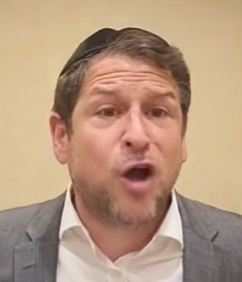

**Rabbi Shlomo Farhi**

Yeah, I like creating headlines that I hope will catch the reader’s eyes and make him or her read my column. This headline – “Honesty is Not the Best Policy!” was inspired by a story I recently heard on a podcast by Rabbi Shlomo Farhi that can be found on either Torahanytime.com or Chazak. You can access this particular 26- minute lecture by googling – Noach And Nothing But the Truth.

Rabbi Shlomo Farhi is a world-renowned speaker and educator, known for his magnetism and personable style. He was born in Israel and raised in the Syrian community of Deal, New Jersey, in a home saturated in Torah, chesed and tradition. He studied in top yeshivot including Rav Tzvi Kaplan, Mir, and Lakewood, and he obtained his rabbinical ordination from the Jerusalem Kollel of Rav Yitzchak Berkowitz.

**Spiritual Leader of an Upper East Side Synagogue**

Prior to taking over the prestigious position of being rabbi of the Edmond J. Safra Synagogue in the Upper East Side of Manhattan, Rabbi Farhi was a dynamic force in the United Kingdom. He helped create such cutting-edge educational Torah projects in the UK as NEXT, JTAG, and Aish Schools, which are currently educating thousands of young Jews in the United Kingdom, and helping them find direction in their lives.

Rabbi Farhi is also the founder and director of Chazak, a Sephardic educational organization, and was the director of Jewish Leadership Foundation, whose mandate is to identify and nurture future leaders for Jewish communities worldwide

Several times a week Rabbi Farhi delivers in the Edmond J Safra Synagogue a Breakfast in the Class shiur including the previously mentioned lecture from Parshat Noach – “And Nothing But the Truth.” These Breakfast in the Class lectures can be accessed by googling – Rabbi Shlomo Farhi – Torahanytime.com

Getting back to the title of this review, Rabbi Farhi in his “And Nothing But the Truth” lecture, he recalled that many years ago, there was a very wealthy and powerful man who got up to speak in his father’s shul in Deal, New Jersey. My father introduced him and this man began by declaring “rabbotai, honesty is not the best policy.”

**“What is Happening Here?”**

Everybody is looking at my father, the rabbi wondering “What is happening here?”

The man then repeated – “honesty is not the best policy. Honesty is the only policy.! You don’t have any other options! You want to know how I became successful in business? By never messing over anybody. My word was 100% bankable and you could go to the bank on it. You didn’t need a contract when doing business with me.

“Yes, there were a few times when I lost out on some deals. My honesty meant that mine was not the lowest bid. But you want to know what happened next?. People instead of giving me the business would take someone else’s lowest bid because it was cheaper.

“But then they discovered that the other person, my competitor was a liar. He gave them a point lower than my bid but they paid dearly for it when they had to sit down at the business table with him.

“So, the next time, they gave me the job and once I fulfilled my part of the bargain, they stayed with me forever. Therefore, I can declare that honesty is not the best policy. It is the only policy.”

Other recent Rabbi Shlomo Farhi Breakfast in the Class lectures that can be found by googling – Rabbi Shlom Farhi – Torahanytimes.com. included “The Blessing of a Good Name,” “Now What?,” “Nothing is Impossible,” and “Not WHAT But How.”

*Reprinted from the November 18, 2922 edition of The Jewish Connection.*

**Rav Avigdor Miller on**

**Rock and Roll Music**

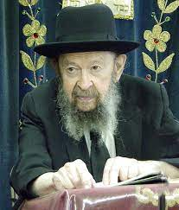

**QUESTION: Is it forbidden to listen to rock and roll music? ﻿**

**ANSWER:** The answer is no, it’s not forbidden. Isn’t that surprising, for me to say that? It’s also not forbidden to walk out onto Ocean Parkway, take off your shoes and dance a jig. It’s not forbidden. Only that you’re a meshugeneh if you do it. And you very well might get a tack in your foot.

And if you listen to rock and roll, you’ll get some tacks in your brain. There’s no question it’s not going to make you any smarter. But if you’re asking if it’s forbidden, I can’t tell you it’s forbidden.

*Reprinted from the November 10, 2022 email of Toras Avigdor (Tape #98 – December 1975).*

**QUESTION:** **Is it proper for a boy to perform in a concert?**

**ANSWER:** It depends what kind of concert. If it’s a concert that’s held, let’s say, in the yeshiva for yeshiva men, so on certain occasions, yes, it’s proper. On Purim certainly; on some other occasions as well. But as far as a concert that is done for the public, I’m going to reserve my opinion. Because sometimes the atmosphere at these so-called Orthodox concerts is not what it should be. There is a lot of mixing, and leitzanus, and it looks a good deal like a rock and roll gathering. And therefore, it’s not in the spirit of the Torah to come together just to hear singing, just to hear singing alone.

I wouldn’t say it’s forbidden; I’m not going to disapprove of it, but it’s not the derech of the Am Hashem to come together to hear singing. When people are performing mitzvos and they sing while doing the mitzvos that’s a different story –  it’s avodas Hashem. They sing shabbos zemiros, they sing at the simchas beis hashoeiva, or simchas yom tov – that’s a different thing. But to come together in a hall specially for singing, that’s not the Jewish method of doing things. It’s an imitation of the umos ha’olam and therefore I’m not so enthusiastic about it.

*Reprinted from the November 10, 2022 email of Toras Avigdor (Tape #910 – March 1993).*

*\*\*\*\*\*\*\*\*\*\*\*\*\*\*\*\*\*\*\*\*\*\*\*\*\*\*\*\*\*\*\*\*\*\*\*\*\*\*\*\*\*\*\*\*\*\*\*\*\*\*\*\*\*\*\*\*\*\*\*\*\*\*\*\*\*\**

*"And stay with him a few days, until your brother's fury turn away; until your brother's anger turns away from you, and he forgets that which you have done to him" (Gen. 27:44-45)*

Rebecca was aware that Jacob hated Esau, just as Esau hated Jacob. So, she repeated the words "until your brother's anger turns away." Jacob asked her how he would know when Esau was no longer angry at him, and Rebecca replied, "When you yourself are no longer angry." *(Pardes Yosef)*

*Reprinted from the Parshat Toldot 5758/1998 edition of L’Chaim. Adapted from Vedibarta Bam - By Rabbi Moshe Bogomilsky*

**Why Did G-d Have to Cause**

**Isaac to Become Blind?**

**From the Talks of the Lubavitcher Rebbe**

**Rabbi Menachem Mendel Schneerson, Zt”l**

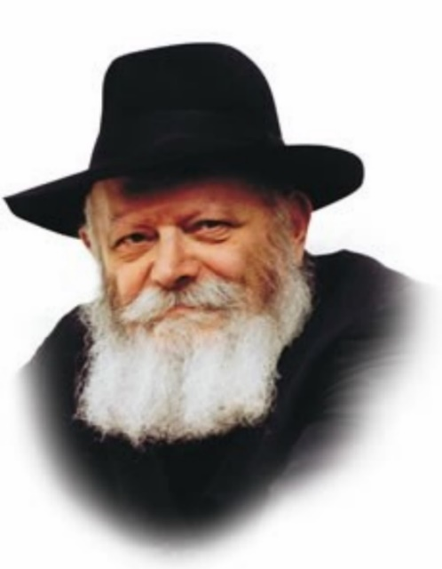

In this week's Torah portion, Toldot, we read of our Matriarch Rebecca's barrenness; the subsequent birth of her and Isaac's twin sons, Esau and Jacob; the twins' growth into adulthood; and the blessing of the firstborn which Isaac bestows upon Jacob.

Isaac became blind in his old age, as it states in this week's portion: "And it came to pass, when Isaac was old, and his eyes were too dim to see." Isaac remained sightless for many years, unable to even leave his home because of his infirmity. One explanation offered by Rashi (the foremost Torah commentator) for Isaac's blindness is that he lost his sight "so that Jacob could receive the blessings."

Isaac did not know that his son Esau was a rasha, an evil person; thus, when he grew old he wanted to bless him. G-d, however, knew that Esau was unworthy and that the blessings should go to Jacob. What did He do? He caused Isaac to become blind, allowing Jacob to come to him in stealth and receive the blessings that were intended for Esau. Had Isaac been sighted he would have been able to distinguish between his sons, and Esau would have ended up the recipient of his blessings.

A question is raised: Why was it necessary for Isaac to suffer for so many years just to ensure that Jacob received the blessings? Couldn't G-d have arranged for Jacob to receive the blessings in another manner? Indeed, Isaac knew that Esau was not as virtuous as his brother; he realized that "the name of heaven" was not usually on Esau's lips. Surely G-d could have simply told him that Esau was an evil person; Jacob could then have received the blessings without Isaac's becoming blind. Why didn't G-d simply reveal the truth to Isaac?

The answer has to do with G-d's reluctance to speak lashon hara (slander), even against as evil an individual as Esau. Despite the fact that Esau was a rasha, G-d refrained from saying so outright. The Torah thus emphasizes the degree to which we must avoid committing this transgression.

If G-d could restrain Himself from speaking lashon hara against Esau, how much more so must we be careful to avoid speaking lashon hara about any Jew! For every Jew, in his heart of hearts, is good.

By emulating G-d's ways and being careful in what we say, we fulfill the mitzva of safeguarding our tongue.

*Reprinted from the Parshat Toldot 5758/1998 edition of L’Chaim. Adapted from Likutei Sichot, Volume 15.*

***"May G-d grant you the dew of heaven... Nations will serve you... (Gen. 27:28, 29)***

The first blessing Isaac gave to Jacob was the dew from the heavens. This refers to the special dew G-d will use to bring the dead back to life at the time of the Resurrection of the Dead in the Messianic Era. Isaac also blessed Jacob that ot hers nations would serve him. G-d gave the same promise for the times of the Redemption, as it says in Isaiah, "Kings will be your babysitters and princesses your nursemaids." *(Breishit Rabba)*

*Reprinted from the Parshat Toldot 5758/1998 edition of L’Chaim. Adapted from Vedibarta Bam - By Rabbi Moshe Bogomilsky*

**Rabbi Berel Wein on**

**Parshas Toldot**

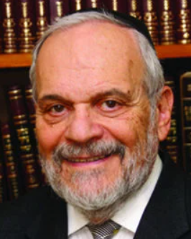

In the competition between the brothers Esau and Jacob, Esau originally downplays any long-range view of the situation. He demands immediate gratification and is therefore more than willing to relinquish his birthright – which is only a long-range asset – in favor of an immediate bowl of hot lentils. As the Torah dutifully records for us in this week's reading, Esau will come to regret this youthful decision later in life. But, like almost all of us, he will put the blame for the mistake on others – on the shrewdness of Jacob taking advantage of him – rather than on his own error and weakness.

By blaming Jacob for what was his own short sidedness, Esau compounds the original error of judgment on his part. After having tasted all the immoral pleasures of life, and after a career of violence, Esau remains unfulfilled, unhappy and frustrated. He now longs for the blessing and approval of his old father, a person who he has long treated as being completely irrelevant to him.

His shout of anguish, when he realizes that the spiritual blessings of his father have already been bestowed on his brother Jacob and that what is left for him are the fleeting blessings of temporal existence and power, reverberates throughout human history. He realizes that the blessings given to Jacob are those of eternity and lasting memory while all physical blessings in this world are merely temporary and always subject to revision. The Torah always deals with eternal standards and never bows to current themes and ideas no matter how attractive they may seem at the time.

Every generation feels that it discovers new ways to propel humanity and civilization forward. Somehow, we always feel ourselves to be wiser than our elders, smarter than our ancestors. But, if one makes an honest review of human history, it becomes clear that the true principles of civilization – morality, kindness, education and individual freedom – remain constant throughout the story of humankind. Deviations from these principles, in the hope of achieving a utopian society, have always resulted in tragedy and destruction.

The cry of Esau reverberates through the halls of world history. And, what makes it most pathetic is that what Esau is searching for can easily be found in what he himself has previously discarded and denigrated. But, it is always the egotistical hubris of humankind that prevents it from seriously and logically examining its situation and thoughts. One has to admit to past errors and to restore oneself to the path of goodness and righteousness, which alone can lead to a lasting feeling of happiness and accomplishment in this world.

Esau would like to be Jacob, but without having to behave with the restraint and outlook on life that is the most central point of reference in the life and behavior of Jacob. It is as Justice Brandeis once put it: “I would like to have the serenity and peace of the Sabbath but without its restraints.” It is dealing with that fallacy of thought that makes Jacob Jacob and Esau Esau.

Shabbat shalom

*Reprinted from this week’s Parshat Toldot 5783 website of rabbiwein.com*

**That My Soul May**

**Bless You (27:4)**

Why did Isaac want to bless Esau instead of Jacob? Jacob was "a pure man, a dweller in tents (of Torah)," and even without a blessing he would stay away from evil. Esau, however, was very likely to fall into bad ways, and needed the assistance of his father's blessing. (Ohr HaTorah)

*Reprinted from the Parshat Toldot 5783 email of R’ Yedidye Hirtenfeld’s whY I Matter parsha sheet for the Young Israel of Midwood in Brooklyn.*

**U.S. Postal Service Issues New Hanukkah Forever Stamp**

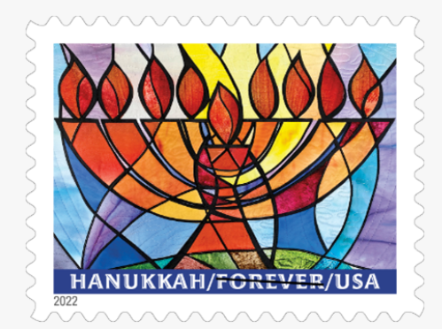

**CHAGRIN FALLS, OH** — With the release last month [on October 20th] of this vibrant new stamp, the U.S. Postal Service continues its tradition of issuing stamps for the Hanukkah celebrations.

This joyous Jewish holiday commemorates the liberation and reconsecration of the Temple in Jerusalem in the second century B.C. Also known as the Festival of Lights, Hanukkah is a time for family and friends to come together to rejoice.

The stamp art features the design from an original wall-hanging. The fiber art was hand-dyed, appliquéd and quilted to form an abstract image of a hanukkiah.

The blue and purple colors are used to represent the sky, the greens and browns represent the earth. The bright yellows and oranges represent the Festival of Lights, as Hanukkah is also known. Along the bottom of the stamp, the words Hanukkah, Forever and USA appear in white capital letters.

Jeanette Kuvin Oren was the stamp designer and artist. Ethel Kessler was the art director.

***Excerpted from a U.S.P.S. press release.***

**Bubby and Birnbaum**

**By Marla Brown Fogelman**

***A once-acclaimed author of essential prayer books—and my grandmother’s friend—belatedly gets the gravestone he deserves***

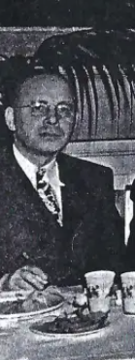 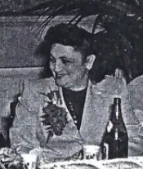

**Dr. Philip Birnbaum and the author’s grandmother at an annual dinner for the Associated Hebrew School in Wilmington, Delaware that Dr. Birnbaum headed as principla for 20 years until moving to Manhattan in 1963.**

On a bright October afternoon, my husband and I joined a group from Manhattan’s Jewish Center synagogue for an unusual memorial event at the vast Sharon Gardens cemetery in Valhalla, New York: the gravestone rededication ceremony for once-acclaimed prayer book author Dr. Philip Birnbaum, whose 1988 *New York Times* obituary described him as the “most obscure best-selling author.” Birnbaum, who wrote the groundbreaking [Siddur Ha-Shalem](https://archive.org/details/PhilipBirnbaumHaSiddurHaShalemTheDailyPrayerBook1949), was a member of the Jewish Center for the last several decades of his life, but according to most people, kept to himself and usually said “no, thank you,” to invitations for Shabbat meals.

**Mirroring the Influence Birnbaum**

**Had Even After His Death**

Yet even though only a few here knew him, about 15 showed up in person at the rededication and many others joined on Zoom—whether out of respect for a scholar, community obligation, or *chesed shel emet*, the act of performing a final kindness for a deceased individual. It also mirrored the influence that Birnbaum had on my life and others after his death.

Although I never knew Birnbaum, I heard his name mentioned frequently and in reverential tones throughout my Wilmington, Delaware, childhood—especially by Bubby, my grandmother, a Hebrew-school teacher who studied with Birnbaum and was one of the original members of the Hug Ivri, a Hebrew-speaking group that Birnbaum founded in January 1946, and of which my 93-year-old mother is still a member. By most recent reports, it is the oldest continuing gathering of its kind in the United States.

It was during his 20-year stint in Wilmington, where Birnbaum headed the Associated Hebrew School, that he published both his Siddur-Ha-Shalem and a High Holiday prayer book (*machzor*); decades later, they often remain the go-to prayer books for some traditionally observant Jews.

**Bubby Was One of Birnbaum’s**

**Most Ardent Admirers**

According to a *Wilmington News Journal*article at the time of the siddur’s 1949 publication, Birnbaum himself was amazed at the reception that Siddur Ha-Shalem received. However, it was no surprise that Bubby was one of Birnbaum’s most ardent admirers both during his time in Wilmington and after he moved to New York in 1963.

An aspiring Judaic scholar who also wrote fan letters to rabbis, Bubby was in awe of Birnbaum’s brilliance as well as his passion for using precise and proper language, whether in Hebrew, English, or Yiddish.

So, I believe she would have been appalled to learn that, until four months ago, Birnbaum’s gravestone featured a spelling error in his first name (Phillip rather than Philip), an incorrect birth year (1905 rather than 1904), and another spelling error in his description (“a renouned author”). But I also have no doubt that she would be pleased that, thanks to the diligence and persistence of a young Maryland lawyer, writer, and Yeshiva University graduate named Yosef Lindell, Birnbaum has finally gotten a more fitting headstone, which is the reason that we gathered in October.

Bubby may have wondered how these mistakes were made. Or she may have understood why it happened that an unmarried man with no children, or close relatives living in the United States, had no one to properly weigh in on or vet his gravestone either at the time of the first unveiling or on subsequent visits to the cemetery.

Which helps explain why it took 34 years for this gravestone rededication to occur and only after Lindell, who had been doing research on Birnbaum’s prayer books and other works, discovered the problem from a photo he’d seen on Twitter. After noting both the errors and the absence of any Hebrew text on the gravestone, he decided to take action.

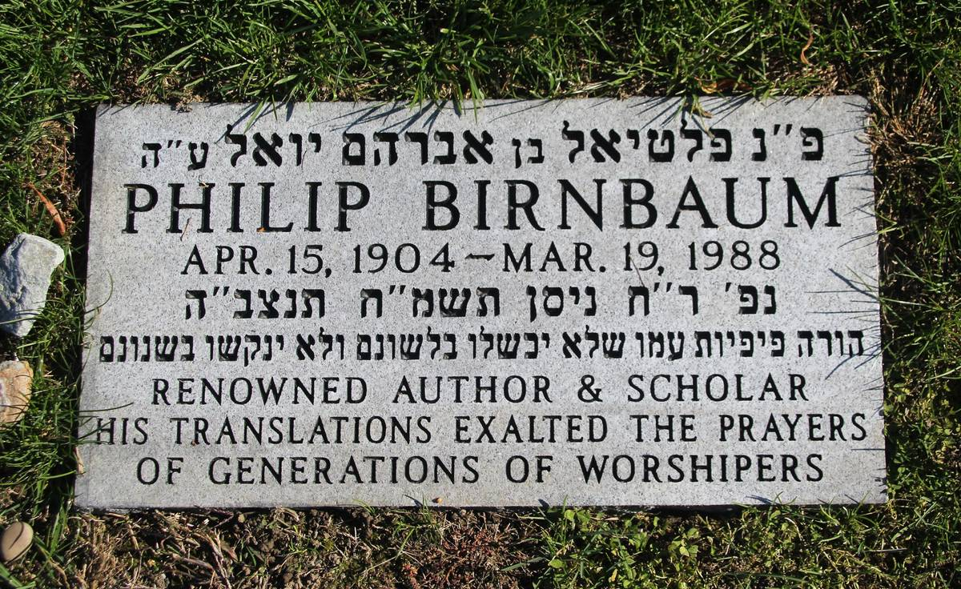

**The new headstone – courtesy of the author**

As Lindell tells it, he reached out first to his YU mentor, Rabbi J.J. Schacter, a senior scholar and professor of Jewish history and Jewish thought at YU, and then to Rabbi Yosie Levine, the current rabbi of the Jewish Center, who put him in touch with former Jewish Center President Larry Kobrin.

With Kobrin, who is also a lawyer, Lindell checked court files and searched other records so that they could move ahead to change the stone. Eventually, they did discover the name of the executor of Birnbaum’s will, who is also long deceased. With the help of a genealogist, Lindell eventually got the name of a nephew in Israel, but it took a while to track him down and make contact with his family.

Replacing a headstone can be a long, drawn-out process, but Kobrin was able to raise the funds within only a few weeks from Jewish Center members who had known Birnbaum. “It was relatively easy,” Kobrin told me.

Kobrin also planned the day’s tribute, which consisted of the memorial service at the cemetery, followed by a Zoom presentation at the Jewish Center, given by Lindell, for a larger crowd of synagogue members and others.

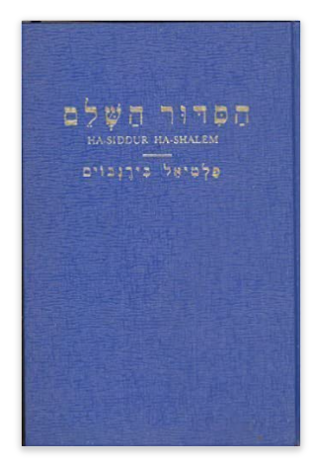

**Cover of Philip Birnbaum’s**

**Popular translation of the Siddur**

Before coming, I wondered how this unveiling might differ from others I’ve attended, most recently for my uncle, who had himself claimed (true or not) that he had helped Birnbaum edit his siddur.

But this memorial service for Birnbaum followed the same format as others, albeit with the participation of revered and eminent rabbis. That day, near Birnbaum’s gravestone, the service began with remarks by Rabbi Levine, who made a cogent point about community standing in for family and then introduced Rabbi Schacter as “*moreinu rabbeinu*” (our teacher, our rabbi).

After reciting the customary [Psalm 23](https://www.sefaria.org/Psalms.23?lang=he-en&utm_source=tabletmag.com&utm_medium=sefaria_linker), Rabbi Schacter asked Lindell, his former student, to formally uncover the gravestone, lauding him for “your dogged determination, your incredible interest, your focus, your undying commitment to see this happen.” He also quoted various Jewish sages on how it only takes one person to make a “massive difference.”

*“*Yosef taught us and continues to teach us what one person can do,” said Schacter*.*

Schacter, who became rabbi of the Jewish Center in 1981, related a story about being worried about

Birnbaum’s reaction during Schacter’s “tryout Shabbos”: “He was, for me, from the distance, a forbidding figure. He was extremely famous, sat two rows in front of Dr. Lamm,” Schacter said. “I tried very hard not to look over there. So, I looked over at Larry’s friendly happy face and felt comfortable,” Schacter continued, referring to Kobrin, and we in the crowd chuckled.

**Dr. Birnbaum’s Seal of Approval**

Schacter told us he was relieved to hear, from the shul president, that Birnbaum had said his speech was “amazing.” “I think that’s what sealed it for me, if I got the *gushpanka* [seal of approval] from Dr. Birnbaum, must be that it was a good sermon.”

Lindell, the final speaker, told the crowd what drove him to correct the gravestone and the genesis for his research on Birnbaum, which stemmed from discovering that Birnbaum’s 1951 High Holiday prayer book was still in use at the synagogues where he led services. “If my research taught me anything, it’s that Dr. Birnbaum cared deeply for the Hebrew language. And he cared deeply about accuracy,” said Lindell.

In describing his quest to correct the errors, Lindell said he also felt compelled to add a Hebrew verse from the High Holiday prayers, but one that would be in keeping with Birnbaum’s opinions that inscriptions on grave markers should be modest: “He instructed the mouths of his nation so that their tongues should not falter and that they should not err in their language or falter in their speech.”

Like Lindell, I think Birnbaum would have approved of this verse, as well as have been gratified that such a bright and learned young man as Lindell was the driving force in correcting and replacing his monument.

**Ended with a Group Kaddish and Kel Maley Prayer**

Perhaps Birnbaum would also have approved of this short and modest ceremony, which like other traditional unveilings, ended with a group Kaddish and the *Kel Maleh* prayer.

Later, I would attend Lindell’s presentation and find out more about “the man behind the *machzor*,” as Lindell characterized him—but in the quiet of the cemetery, I just wanted to meditate on my own decades-overdue gratitude to Birnbaum and for what he imparted to my family and my hometown. I wondered if he, like my beloved childhood rabbi, Leonard Gewirtz, of blessed memory, also made it a mission to heighten Jewish learning and observance in Wilmington’s small Jewish community.

But I have no doubt that it was Birnbaum’s influence that led Bubby to stuff me with lessons in Hebrew, the Five Books of Moses*,*and Ethics of the Fathers (*Pirkei Avot)*, in addition to roast chicken, noodles, and apple cake—at weekly lunches at her house throughout my elementary school years.

A woman rich in opinions, Bubby may have also taken issue with the characterization of Birnbaum as an “obscure author.” However, Birnbaum himself may have been less concerned with name recognition than what people could glean from his prayer books and other works, including a Haggadah, an Encyclopedia of Jewish Concepts, The Concise Jewish Bible, as well as his own version of *Pirkei Avot*.

As Lindell told me, “I get the sense from what Birnbaum writes, that he wasn’t looking for fame. He was looking to educate people.”

*Marla Brown Fogelman is a freelance writer in New York City. Her work has appeared in The Washington Post, Parents, The Forward, Moment, and other national and regional publications.*

*Reprinted from the November 16, 2022 website of Tablet Magazine.*

**Thoughts that Count**

***"Please pour into me some of this red stuff" (Gen. 25:30)***

It seems strange that someone as coarse and ill-mannered as Esau, would use the word "please." The Hebrew word for "please," na, can also be translated as "raw." Because Esau was so hungry and so lacking in manners, he gruffly ordered Jacob pour some of the "raw red stuff" down his throat. *(Iturei Torah)*

***And Jacob said, "Sell me this day your birthright." (Gen. 25:31)***

This transaction took place on the day of Abraham's passing. But, while the whole world was mourning this great loss, his own grandson Esau was out hunting. When Jacob discovered this, he resolved to acquire the birthright, saying to Esau, "Sell me your birthright because of what happened this day. You are unworthy of so lofty a spiritual identity." *(Harav B. Berzan)*

*Reprinted from the Parshat Toldot 5758/1998 edition of L’Chaim. Adapted from Vedibarta Bam - By Rabbi Moshe Bogomilsky*